AGILE METHODOLOGY & BANKING DOMAIN

AGILE METHODOLOGY & BANKING DOMAIN

**Introduction :**

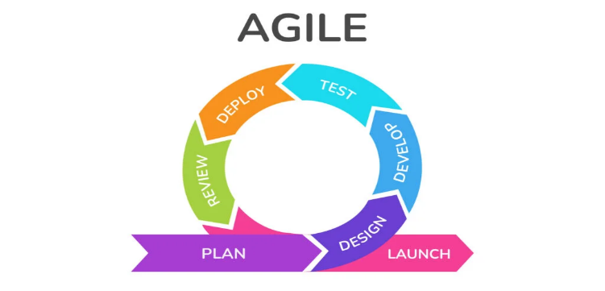Agile methodology is an iterative and incremental method to software development that prioritize flexibility, collaboration, and customer satisfaction. Agile emphasizes the delivering the working software in short, frequent cycles known as sprints. Responding Quickly to the change is the key aspect of Agile software development.

**MoSCoW Principle:**

This principle is used on agile to prioritize the tasks. It stands for **M**ust **S**hould **C**ould **W**on’t. It helps to understand which task should focus first.

**When to use Must, Should, Could and Won’t?**

First list all the requirements. The task is considered under :

Must - If it is very important for the completion of project and without that the project will fail.

Should - The task under should also important but they can be delayed, they are not time critical.

Could – The requirements or tasks are not necessary, but it can be completed if there is time to complete it.

Won’t – The task under this are of least important and can be completed at later stages.

**Sprint:**

A sprint is a fixed period in a development cycle where teams complete their tasks. Typically, it lasts for 2 to 4 weeks but exact duration can vary depending on the project and team. Each sprint should have clear set of objectives and deliverables. When the sprint starts, no change is allowed to sprint items.

**Important terms used in Agile:**

1. **Product Owner:** Member of agile development team who defines the requirements.
2. **Scrum Team:** It consists of the individuals who are responsible for delivering the product increment within a sprint. Scrum team involves individuals like Developer, Tester, UX Designer, Software architect, deployment Team etc.
3. **Scrum Master:** The scrum master makes sure that the delivery is done in time and the needs of the team is met.

**Product Backlog:**

Product backlog is a prioritizes list of everything that needs to be done to the product which includes all the features, enhancement, bug fixes and other works that need to be done for the product.

**After obtaining the requirements what to do?**

After specifying the requirements, product owner identifies the features and then extracts the epics from it. Then epics are broken down into smaller items called as stories by the product owner. Once the stories are created then scrum team is responsible for breaking those stories into tasks.

**Epics:**  Epic is a large, high-level requirement that represents a significant body of work. It can be divided into multiple stories. It spans for multiple sprints.

Example: Search system.

**Stories:** A user story is a small, requirement written from the user’s perspective. It describes the specific task or features that delivers the value to the user. It can be completed in in single sprint. User stories captures the who, why and what of requirements.

Typically, the following template is followed:

As a <User>

I want to <Perform Action>

So that I can <See Results>

Example: As a customer, I want to filter search results by price, So that I can find the products within my budget.

**Task:** It is the smallest unit of work within the user story. It represents the specific actions that need to be completed to implement the story or epic. Tasks are typically estimated in terms of times or effort and assigned to individual team members for implementation.

Example: Create user interface for password reset functionality.

**Release:**

It refers to the final delivery of a functional software increments to the users.

**Release Plan:**

It is a roadmap that outlines the schedule and scope of planned releases for a product. It provides the It helps to ensure that the product evolves in a structured and intentional manner and delivering incremental values with each other.

**Story Points:**

It is a unit to estimate the relative size or effort required to implement a User Story of feature. In story points scale changes not the size or work. For example, in Fibonacci series the larger gaps between estimates allow for easier distinction of complexity.

**Sprint Backlog:**

It is a list of tasks, stories and the work items that the development team commits to completing during a specific sprint.

**Planning Pocker:**

It is a collaborative estimating technique used in Agile to estimate the relative size or effort of the user stories or tasks.

**Product RoadMap:**

It is a document that outlines vision, direction and goals of the product. It provides the timeline of features, enhancement and initiatives.

**Definition of Ready (DoR):**

It is a set of criteria or guidelines that a user story must meet before it is considered ready to be worked on by the development team during sprint planning. Like checking the infrastructure readiness or if database is used then checking that the required tables are there etc.

**Definition of Done (DoD):**

DoD is used to determine if a user story is considered done and ready for the release or demonstration. It focuses on the quality, functionality and completeness of the developed features. For example, like all acceptance criteria are met and tested successfully, unit and integration testing are passed.

**Execution process :**

1. **Sprint planning**
2. **Daily Standup**
3. **Sprint review**
4. **Retrospective**

**Sprint planning:**

It is a collaborative meeting that marks the beginning of the sprint. During the meeting the Product Owner, Scrum Master and Scrum team will come together and plan what work should be completed during the sprint. The purpose of this is to define the goals and tasks for the upcoming sprint.

The product presents the high priority items from the product backlog and then the development team collaborates to select a set of items to work on during the sprint. The team breaks down the selected items into tasks and estimates the efforts and time required to complete and the assigns it to team members.

**Daily Standup:**

It is a brief meeting that occurs everyday during the sprints to synchronize the activities of the team, identify the blockers if any and discuss the progress. It helps to promote transparency and collaboration within the team members and ensure that everyone in team is focusing on achieving their goal. Each team member answers these three questions during daily standup:

1. What did I do yesterday?
2. What will I do today?
3. Are there any obstacles that may block their progress?

**Sprint Review:**

It is held at the end of each sprint and is an opportunity to demonstrate the work completed during the sprint to their stakeholders including PO and customers and gather the feedback.

The team showcases their completed user stories that is completed during that sprint and the stakeholders give their feedback and discuss the value delivered.

**Sprint Retrospective:**

It is held immediately after the sprint review and provides the opportunities for the team to reflect on their process and identify the opportunities for improvement. It lasts for one to two hours per week. In this meeting they discuss what went well, what went wrong and how to improve, what actions they can take to overcome in next sprint.

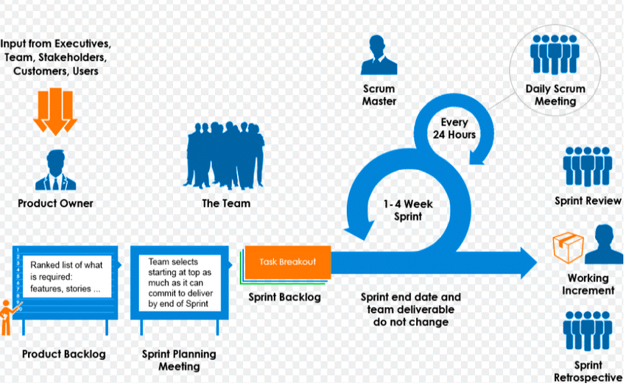

**Values of Agile:**

1. Individuals and interaction over the process and tools.
2. Working Software over comprehensive documentation.
3. Customer collaboration over contract negotiation.
4. Responding to change over following the plan.

**CI/CD:**

CICD stands for Continuous Integration and Continuous Deployment. It is best practice sed to streamline the delivery and ensure code quality and enable rapid and reliable deployment of software updates. It enable the team to deliver value to the customer quickly with high quality.

**Slicing and Dicing of stories based on the INVEST criteria:**

**I**ndependent: User stories should be independent of each other.

**N**egotiable: Stories can be redefined and adjusted through collaboration between team and stakeholders.

**V**aluable: User stories should deliver value to the customer or end user.

**E**stimable: It means that team can estimate the effort required to implement.

**S**mall: User stories should be small enough to be completed within a sprint.

**T**estable: The story should have a clear acceptance criterion that can be verified through testing.

**Edge Testing:**

It refers to the practice of testing the extreme conditions of a system to ensure its reliability, stability etc. It involves identifying and testing scenarios that lie at the extremes of the input domains. It helps to minimize the risk of defects and failures and deliver a high-quality product that meets the needs of users.

**Case Study:**

**Designing a Brochure for Banking System**

**Objective:** Develop a digitalized bank brochure to showcase the bank products, services to the customers.

**Team Formation:** We formed a team having a Product owner, Scrum Master and Scrum Team.

Product owner defined the requirements and defined the features and simplified it into epics and categorized based on the MoSCoW principle. There were 5 epics defined. Then the epics are broken down into stories and then to task. For each epic 5 user stories were listed down as per the format. Conducted Sprint planning meetings and selected initial sprints based on the priority. While designing we conducted the daily standup to discuss the progress, to synchronize and to discuss and find solution about impediments.

After the completion of each sprint we gave a demo to the stakeholders and received the feedback and made changes as per it. After that continued with the next sprint. It is continued until all the sprints are completed and at the end Sprint retrospective is conducted and discussed about what went well, what went wrong and how to improve.

Brochure created by our team:

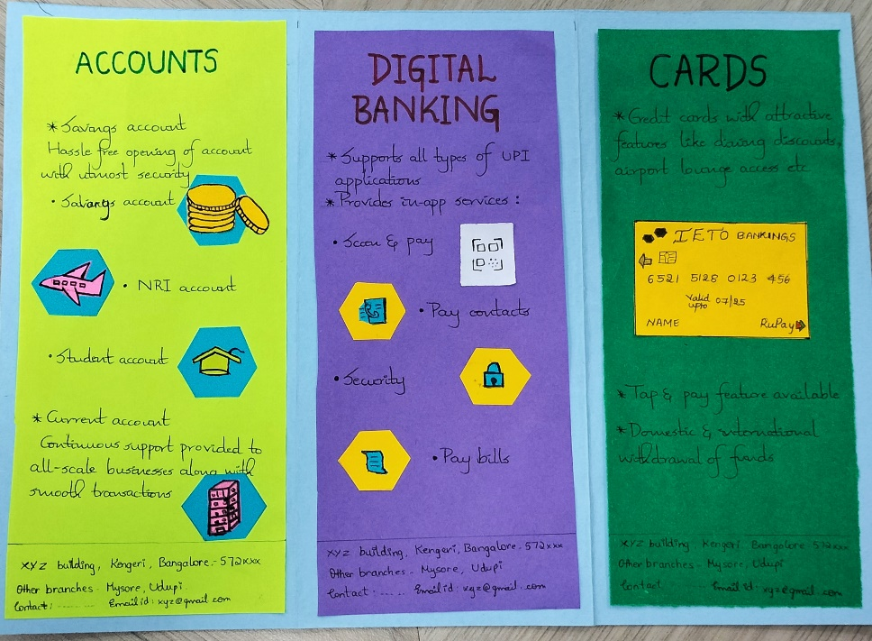

**Conclusion:**

Agile methodologies offer a flexible, iterative approach to software development that prioritizes customer collaboration, adaptability and continuous improvement. By embracing its core principles the team can deliver valuable product faster, adapt to changing needs and foster a more collaborative and satisfying work environment.